Bahria University,

Karachi Campus



LAB EXPERIMENT NO.09

LIST OF TASKS

|  |  |
| --- | --- |
| TASK NO | OBJECTIVE |
|  |
| 1 | **Configure OSPF on the following network and show all necessary configuration steps for each router.** |
| 2 | **Configure OSPF on the following network and show all necessary configuration steps for each router.** |
|  |  |
|  |  |
|  |  |
|  |  |
|  |  |

Submitted On:

Date:

1. **Configure OSPF on the following network and show all necessary configuration steps for each router.**



Solution:

Ip address of Pc’s:

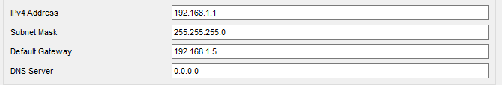 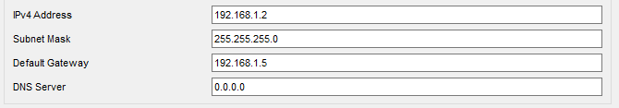 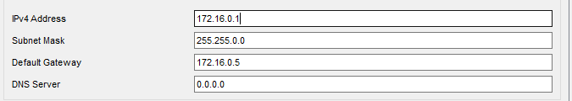 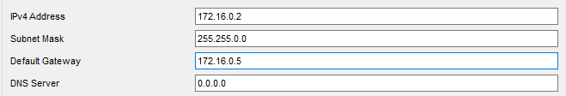

Configuring router 0:

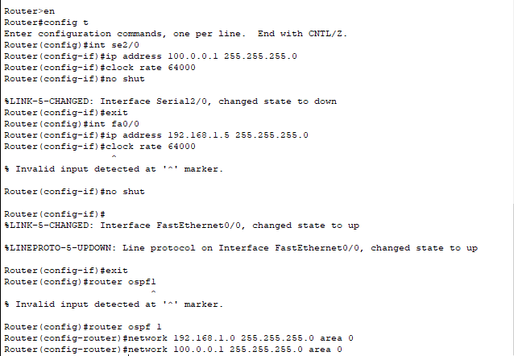

Show Ip route:

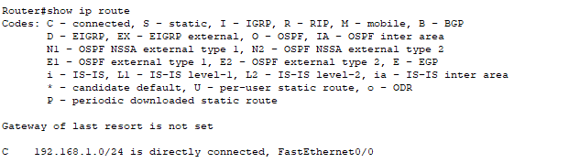

Configuring router 1:

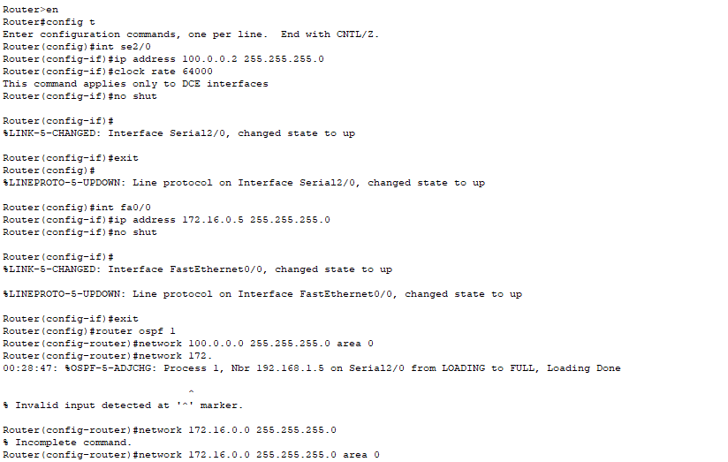

Show Ip route:

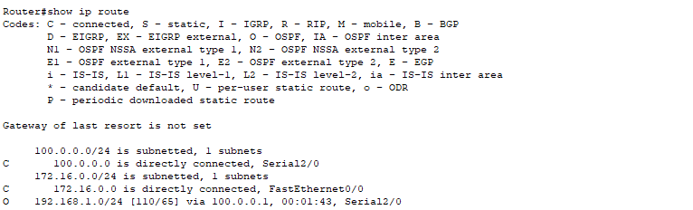

Ping to 192.168.1.1:

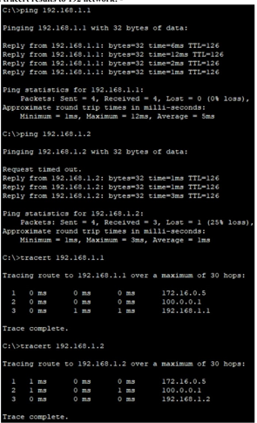

Ping to 172.16.0.1:

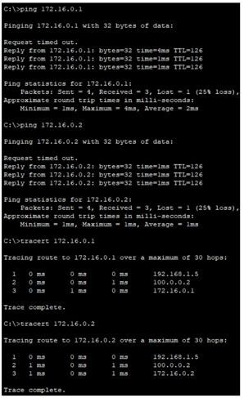

Diagram:

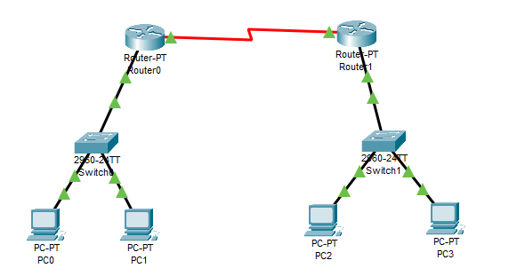

1. **Configure OSPF on the following network and show all necessary configuration steps for each router.**



Solution:

Ip Address:

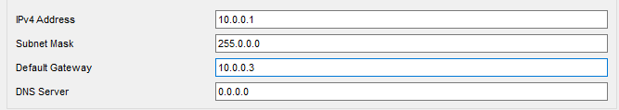

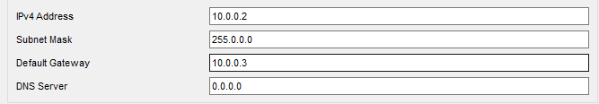 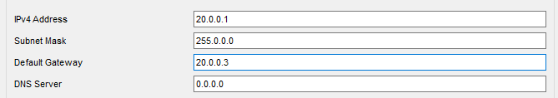 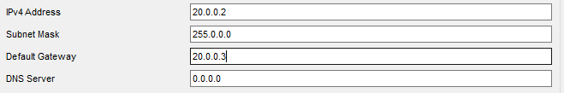

Configuring Router 2:

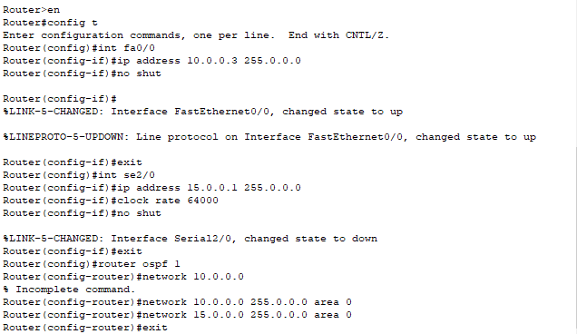

Show ip route:

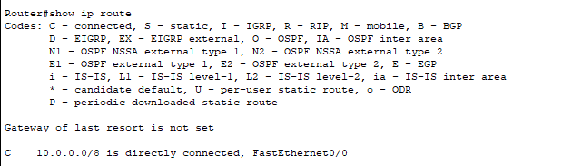

Configuring router 4:

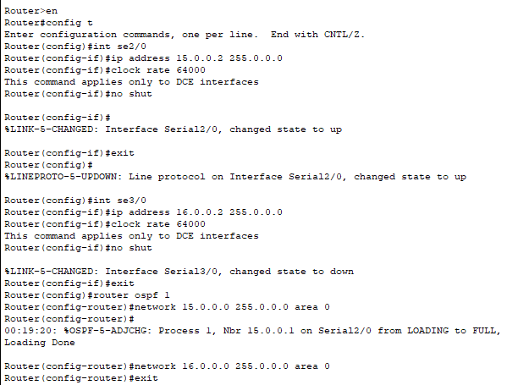

Show ip route:

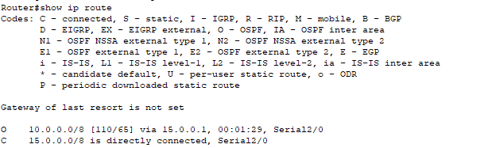

Configuring router 3:

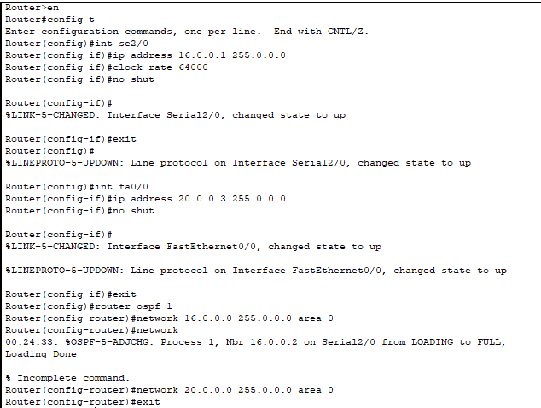

Show ip route:

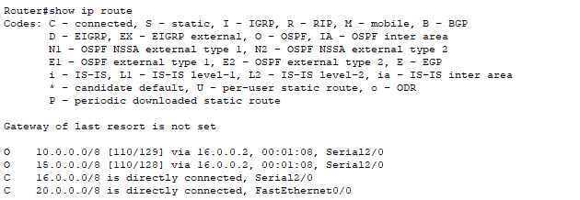

Ping from pc 5 to pc 7:

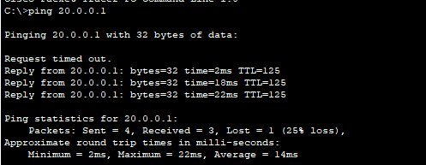

Ping from pc 6 to pc 8:

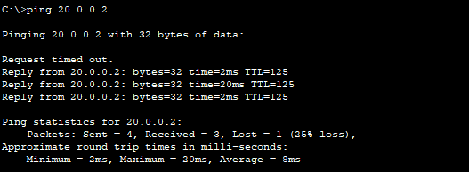

Diagram:

